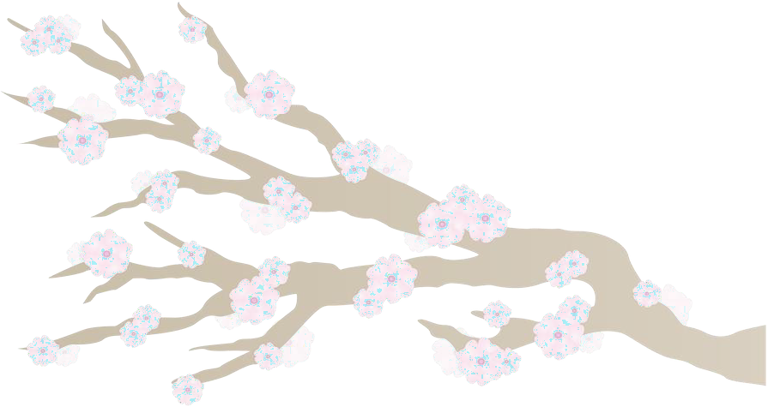

2023 MLTAQ BRISBANE LANGUAGES SPEAKING COMPETITION
JAPANESE DIVISION 1
YEAR 4 SPEECH

 | English guide | Japanese guide
1 | Greeting | hajimemashite  はじめまして
2 | Name
3 | Age | sai desu  (age)さい です。
4 | Grade | yo nen sei desu  四ねん せい です。
5 | 1 Like | ga suki desu  (1 noun) が すき です。
6 | 1 Dislike | ga suki ja nai desu  (1 noun) が すきじゃない です。
7 | Conclusion | douzo yoroshiku onegaishimasu  どうぞ よろしく おねがいします。

- 3 questions will be asked at the completion of the speech.
- The language in the questions will be the same as the language used in the sentences.
- The grammar in sentences 1, 3 to 6 is not to be altered.
- No palm cards or notes are allowed.
- No gestures are to be used other than greeting and farewell.
- Judges will consider accuracy, pronunciation, delivery and responses to questions.

.

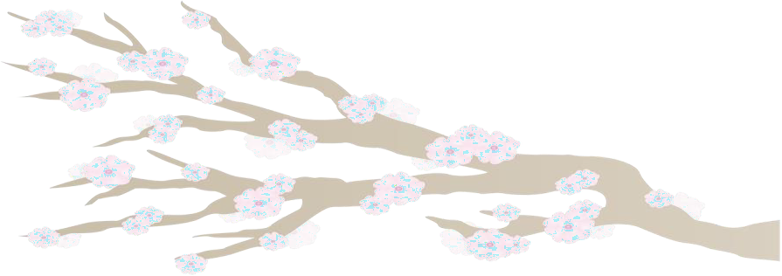
2023 MLTAQ BRISBANE
LANGUAGES SPEAKING COMPETITION
JAPANESE DIVISION 3
YEAR 5 SPEECH

 | English guide | Japanese guide
1 | Greeting
2 | Name
3 | Age
4 | Grade | go nen sei desu.  五ねん せい です。
5 | Where you live | ni sunde imasu  に すんで います。
6 | Hobby | shumi wa desu  しゅみ は （1 noun）です。
7 | 1 Like | ga suki desu  (1 noun) が すき です。
8 | 1 Dislike | ga suki ja nai desu  (1 noun) が すきじゃない です。
9 | Conclusion / Farewell

- 3 questions will be asked at the completion of the speech.
- The language in the questions will be the same as the language used in the sentences.
- The grammar in sentences 4 to 8 is not to be altered.
- No palm cards or notes are allowed.
- No gestures are to be used other than greeting and farewell.
- Judges will consider accuracy, pronunciation, delivery and responses to questions.

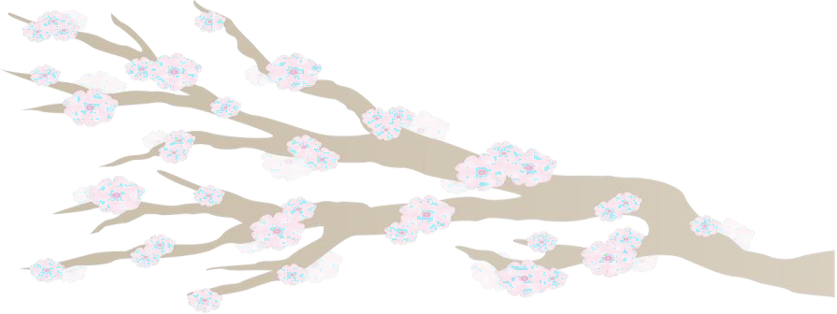
2023 MLTAQ BRISBANE
LANGUAGES SPEAKING COMPETITION
JAPANESE DIVISION 4
YEAR 6 SPEECH

 | English guide | Japanese guide
1 | Greeting
2 | Name
3 | Age
4 | Grade
5 | Birthday | Tanjoubi wa desu  たんじょうび は (month) (date) です。
6 | Where you live | ＿＿＿＿＿＿ ni sunde imasu  ＿＿＿＿＿＿ に すんで います。
7 | 1 Like | ga suki desu desu  (1 noun) が すき です。(adjective) です。
8 | 1 Dislike | ga suki ja nai desu  (1 noun) が すき じゃない です。  desu  (adjective) です。
9 | Number in family | kazoku wa ＿＿＿ nin desu  かぞく は ＿＿＿ にん です。
10 | List family members
11 | Conclusion / Farewell

- 3 questions will be asked at the completion of the speech.
- The language in the questions will be the same as the language used in the sentences.
- The grammar in sentences 5 to 9 is not to be altered.
- No palm cards or notes are allowed.
- No gestures are to be used other than greeting and farewell.
- Judges will consider accuracy, pronunciation, delivery and responses to questions

