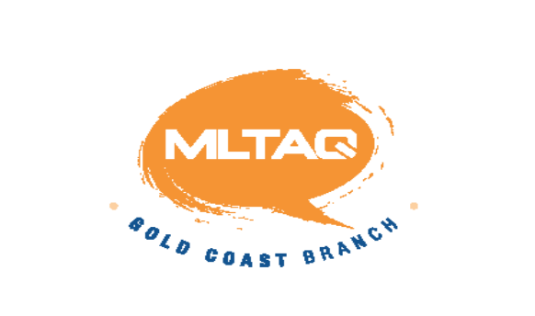
Modern Language Teachers' Association of Queensland
Gold Coast Branch

TAX INVOICE No. MC2021

DATE: ADD PAYMENT DATE 2021

MLTAQ Inc.  Loretta Kishihara  Honorary Treasurer  lkish4@eq.edu.au | CONTACT DETAILS  SCHOOL NAME:  CONTACT TEACHER NAME:  PHONE:  EMAIL:  SCHOOL ABN:
 | Gold Coast Languages Speech Contest - Sunday 25th July 2021

QTY | ITEM |  | AMOUNT
 | Entry fees - $45.00 primary school (per language) |  | $
 | Entry fees - $50.00 secondary school (per language) |  | $
 | Entry fees - $5.00 miscellaneous students (learning a language not taught at the school) |  | $
 |  |  | $
 | GST | (Total divided by 11) | $
 | TOTAL (GST included) |  | $

Please remit the above payment to the following account.
EFT: Account name – MLTAQ Inc.
BSB – 014-526
Account No – 22722 6565.
- Please email a completed copy of this Tax Invoice template to lkish4@eq.edu.au
- A numbered Tax Invoice will be emailed to the school email you provide upon confirmation of payment.

